### **Practical File**

### **Of**

### **Problem Solving Using**

### **Python Programming**

### **SUBJECT CODE: 23CS001**

#### *Submitted*

#### *in partial fulfilment for the award OF the DEGREE*

#### *OF*

**BACHELEOR OF ENGINEERING**

**IN**

**COMPUTER SCIENCE AND ENGINEERING**



**CHITKARA UNIVERSITY**

**CHANDIGARH - PATIALA NATIOANAL HIGHWAY**

**RAJPURA(PATIALA) PUNAJB-140401(INDIA)**

DECEMBER, 2023

**SUBMITTED TO: SUBMITTED BY:**

FACULTY NAME: **DR. MONIKA SETHI** STUDENT NAME**: YASHMEEN** DESIGNATION: **associate** **PROFESSOR(CSE)** ROLL NO. **: 2310991003**

|  |  |  |
| --- | --- | --- |
| Sr. No. | Practical name | Teacher sign |
| 1. | a) Write a [Python Program to Calculate the Area of a Triangle](https://www.programiz.com/python-programming/examples/area-triangle)  b) Write a [Python Program to Swap Two Variables](https://www.programiz.com/python-programming/examples/swap-variables)  c) Write a [Python Program to Convert Celsius to Fahrenheit](https://www.programiz.com/python-programming/examples/celsius-fahrenheit) |  |
| 2. | a.) Write a Python Program to Check if a Number is Odd or Even  b.) Write a Python Program to Check if a Number is Positive, Negative or 0  c.) Write a Python Program to Check Armstrong Number |  |
| 3. | a.) Write a Python program to check if a given number is Fibonacci number?  b.) Write a Python program to print cube sum of first n natural numbers.  c.) Write a Python program to print all odd numbers in a range. |  |
| 4. | a.) Write a Python Program to Print Pascal Triangle  Hint: Enter number of rows: 4  1  1 1  1 2 1  1 3 3 1  b.) WAP to Draw the following Pattern for n number:  1 1 1 1 1  2 2 2 2  3 3 3  4 4  5 |  |
| 5. | Write a program with a function that accepts a string from keyboard and create a new string after converting character of each word capitalized. For instance, if the sentence is “stop and smell the roses” the output should be “Stop And Smell The Roses” |  |
| 6. | a.) Write a program that accepts a list from user. Your program should reverse the content of list and display it. Do not use reverse () method.  b) Find and display the largest number of a list without using built-in function max (). Your program should ask the user to input values in list from keyboard. |  |
| 7. | Find the sum of each row of matrix of size m x n. For example, for the following matrix output will be like this:    Sum of row 1 = 32  Sum of row 2 = 31  Sum of row 3 = 63 |  |

|  |  |  |
| --- | --- | --- |
| 8. | a) Write a program that reads a string from keyboard and display:  * The number of uppercase letters in the string.  * The number of lowercase letters in the string.  * The number of digits in the string.  * The number of white space characters in the string.  b) [Python Program to Find Common Characters in Two Strings](https://www.sanfoundry.com/python-program-check-common-letters-string/).  c) [Python Program to Count the Number of Vowels in a String](https://www.sanfoundry.com/python-program-count-number-vowels-string/). |  |
| 9. | a) Write a Python program to check if a specified element presents in a tuple of  tuples.  Original list:  ((‘Red’ ,’White’ , ‘Blue’),(‘Green’, ’Pink’ , ‘Purple’), (‘Orange’, ‘Yellow’, ‘Lime’))  Check if White present in said tuple of tuples!  True  Check if Olive present in said tuple of tuples!  False  b) Write a Python program to remove an empty tuple(s) from a list of tuples.  Sample data: [(), (), ('',), ('a', 'b'), ('a', 'b', 'c'), ('d')]  Expected output: [('',), ('a', 'b'), ('a', 'b', 'c'), 'd'] |  |
| 10. | a) Write a Program in Python to Find the Differences Between Two Lists Using Sets. |  |
| 11. | a) Write a Python program Remove duplicate values across Dictionary Values.  Input : test_dict = {‘Manjeet’: [1], ‘Akash’: [1, 8, 9]}  Output : {‘Manjeet’: [], ‘Akash’: [8, 9]}  Input : test_dict = {‘Manjeet’: [1, 1, 1], ‘Akash’: [1, 1, 1]}  Output : {‘Manjeet’: [], ‘Akash’: []}  b) Write a Python program to Count the frequencies in a list using dictionary in Python.  Input : [1, 1, 1, 5, 5, 3, 1, 3, 3, 1,4, 4, 4, 2, 2, 2, 2]  Output :  1 : 5  2 : 4  3 : 3  4 : 3  5 : 2  Explanation : Here 1 occurs 5 times, 2 occurs 4 times and so on... |  |
| 12. | a) Write a Python Program to Capitalize First Letter of Each Word in a File.  b.) Write a Python Program to Print the Contents of File in Reverse Order. |  |
| 13. | Write-a-program:-*to catch an exception and handle it using try and except code blocks. |  |
| 14. | Write a Python Program to Append, Delete and Display Elements of a List using Classes. |  |
| 15. | Write a Python Program to Find the Area and Perimeter of the Circle using Class. |  |
| 16. | Create an interactive application using Python's Tkinter library for graphics programming. |  |

**PROGRAM 1**

**A) Write a** [**Python Program to Calculate the Area of a Triangle**](https://www.programiz.com/python-programming/examples/area-triangle)**.**

**SOLUTION:**

b=int(input(“Base of the Triangle:”))

h=int(input(“Height of the Triangle:”))

a=(b*h)/2

print(“Area of the triangle is”, a)

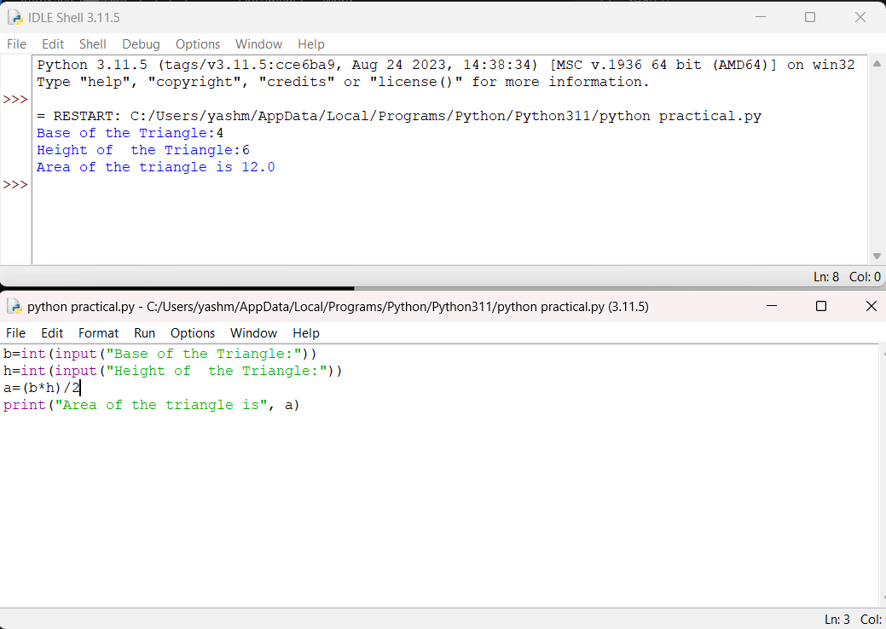**OUTPUT:**

**B) Write a** [**Python Program to Swap Two Variables**](https://www.programiz.com/python-programming/examples/swap-variables)**.**

**SOLUTION:**

n1=int(input(“enter number 1:”))

n2=int(input(“enter number2:”))

print(“original numbers:”,n1,n2)

n1,n2=n2,n1

print(“after swapping:”,n1,n2)

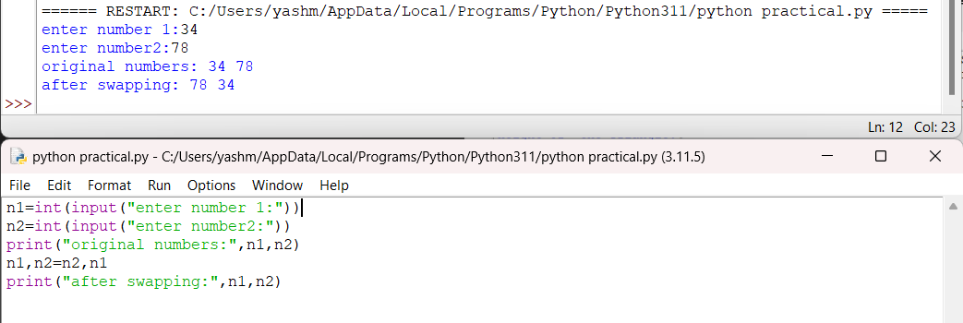**OUTPUT:**

## **C) Write a** [**Python Program to Convert Celsius to Fahrenheit**](https://www.programiz.com/python-programming/examples/celsius-fahrenheit)**.**

## **SOLUTION:**

Cels=int(input(“Enter temperature in celsius:”))

Fahr=Cels*9/5+32

print(“Temperture in Fahrenhite is:”, Fahr)

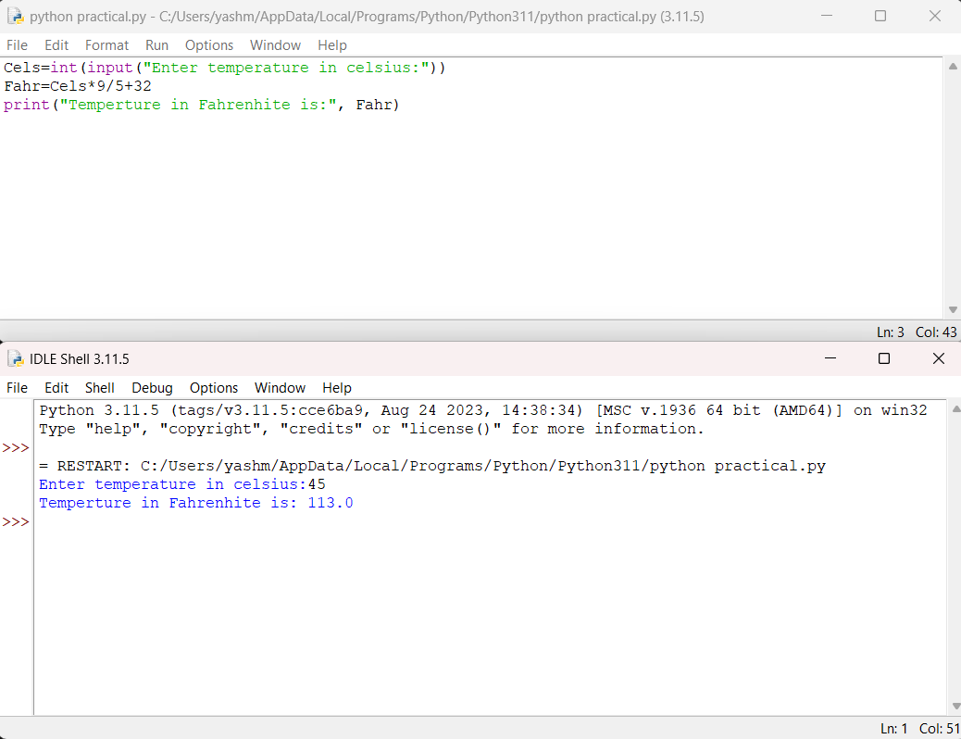**OUTPUT:**

**PROGRAM 2**

**A) Write a** [**Python Program to Check if a Number is odd or Even**](https://www.programiz.com/python-programming/examples/odd-even)**.**

**SOLUTION:**

num=int(input(“Enter a number:”))

if num%2==0:

print(num, “is Even number”)

else:

print(num, “is Odd number”)

**OUTPUT:**

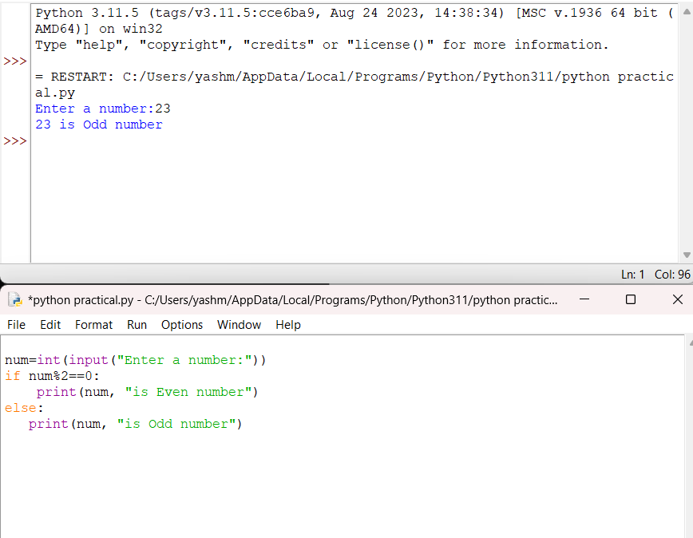

**B) Write a** [**Python Program to Check if a Number is Positive, Negative or 0**](https://www.programiz.com/python-programming/examples/positive-negative-zero)**.**

**SOLUTION:**

### num=int(input(“enter a number:”))

### if(num>0):

### print("Positive")

### elif (num<0):

### print("Negative")

### else:

### print("Zero")

### **OUTPUT:**

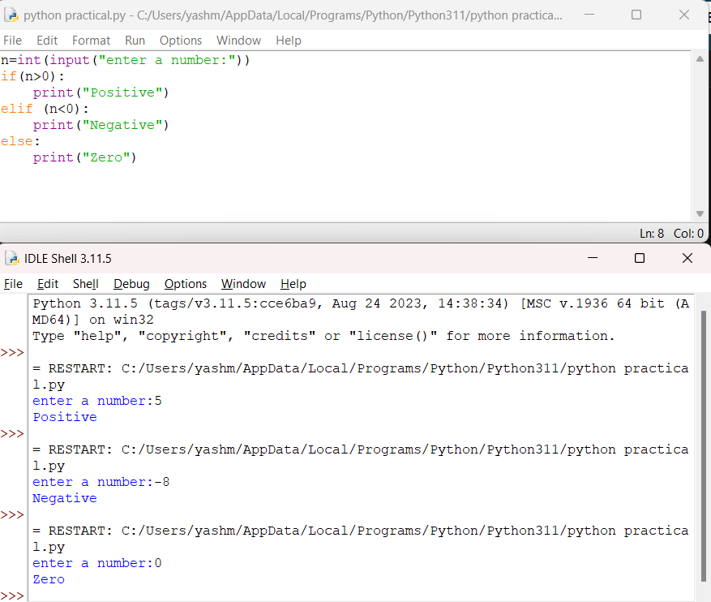

### **C) Write a** [**Python Program to Check Armstrong N**](https://www.programiz.com/python-programming/examples/armstrong-number)**umber.**

**SOLUTION:**

n=int(input(“enter a number:”))

s=n

l=len(str(n))

sum1=0

while(n!=0):

a=n%10

sum1=sum1+(a**l)

n=n//10

if(sum1==s):

print("Armstrong no.")

else:

print("Not an Armstrong no.")

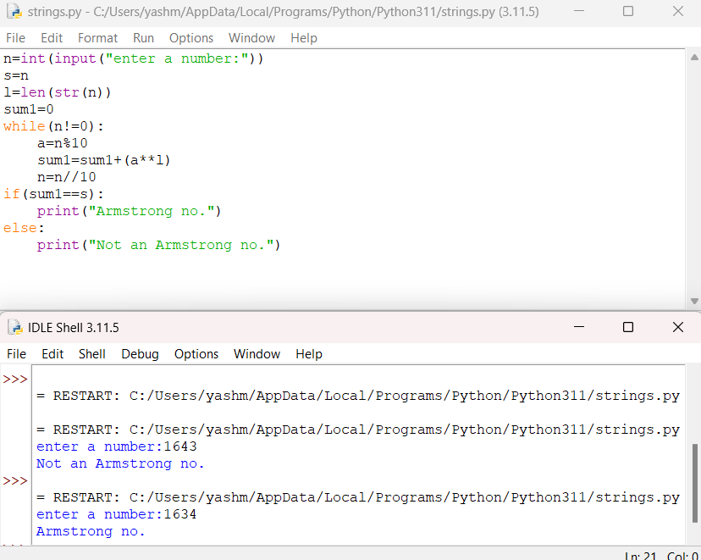**OUTPUT:**

**PROGRAM 3**

**A) Write a Python program to check if a given number is Fibonacci number?**

**SOLUTON:**

n=int(input("Enter the number:"))

c=0

a=1

b=1

if (n==0 or n==1):

print(n,"is a Fibonacci number")

else:

while c<n:

c=a+b

b=a

a=c

if(c==n):

print(n,"is a Fibonacci number")

else:

print(n,"is not a Fibonacci number”)

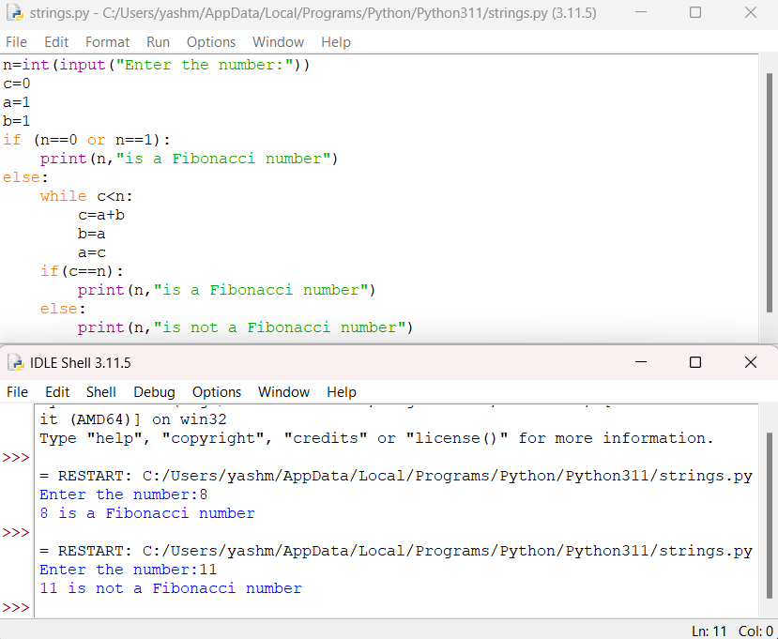**OUTPUT:**

**B) Write a Python program to print cube sum of first n natural numbers.**

**SOLUTION:**

n=int(input(“Enter a Number:”))

s=0

for i in range(1,n+1):

s+=pow(i,3)

print(“cube sum of first n natural numbers is”, n)

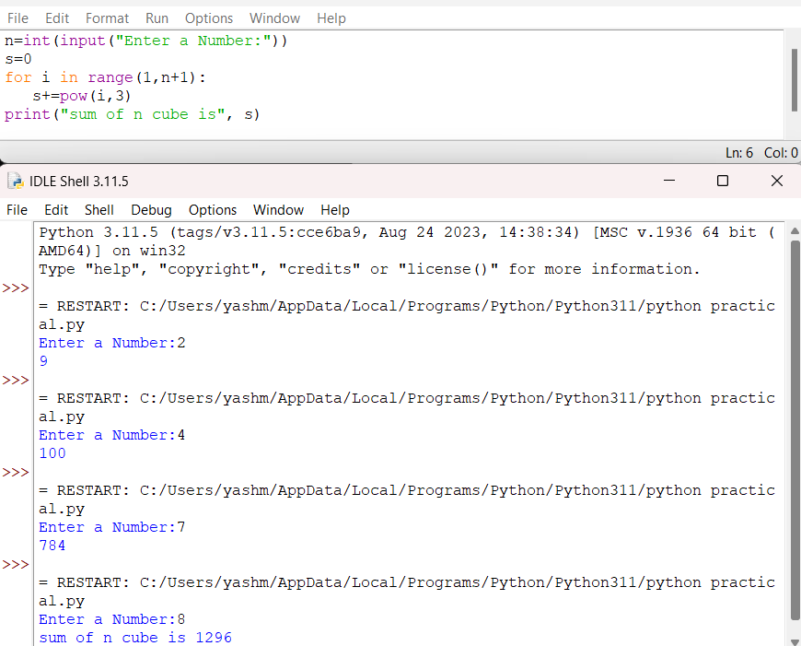**OUTPUT:**

### **C) Write a Python program to print all odd numbers in a range.**

**SOLUTION:**

n=int(input("enter a number:"))

i=0

for i in range(0,n+1):

if i%2!=0:

print(i)

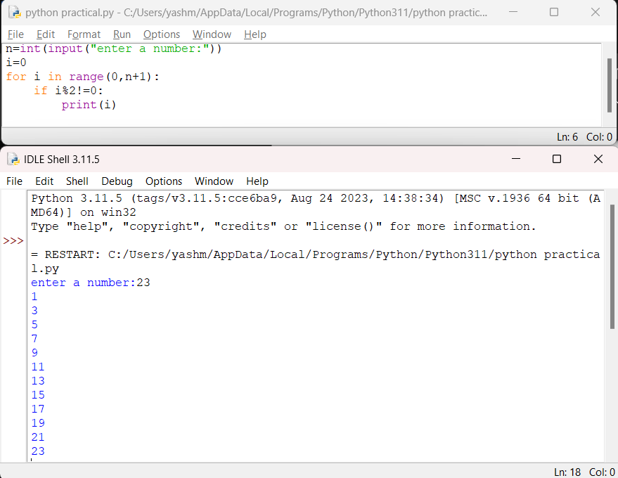**OUTPUT:**

**PROGRAM 4**

### A**) Write a Python Program to Print Pascal Triangle.**

**(Hint:- Enter number of rows: 4)**

### **1**

### **1 1**

### **1 2 1**

**1 3 3 1**

1 3 3 1 )

**SOLUTION:**

n=int(input("Enter the number of rows :"))

for i in range (n):

print(" " * (n-i),end='')

print (' '.join(map(str,str(11 **i))))

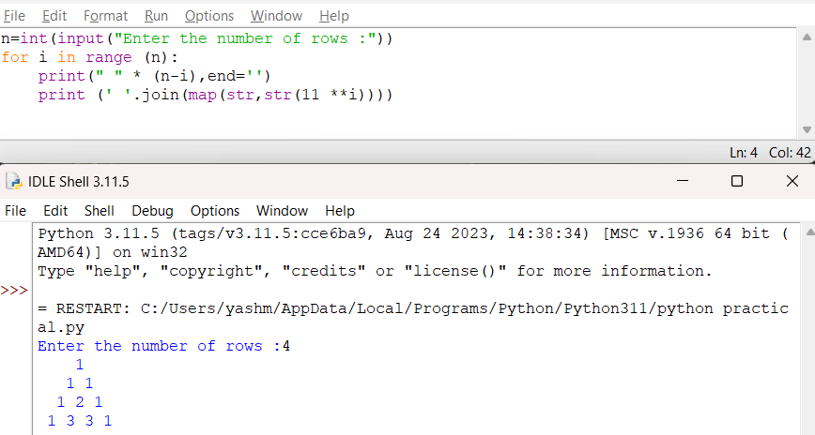**OUTPUT:**

**B) Write a Python Program to draw the following pattern for n number:**

**1 1 1 1 1**

**2 2 2 2**

**3 3 3**

**4 4**

**5**

**SOLUTION:**

n=int(input("Enter the number of rows"))

for i in range(0,n):

for j in range(n-i):

print(i+1, end=' ')

print()

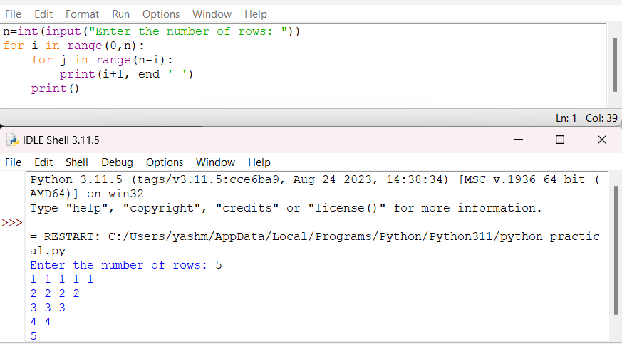**OUTPUT:**

**PROGRAM 5**

**A) Write a program with a function that accepts a string from keyboard and create a new string after converting character of each word capitalized. For instance, if the sentence is “stop and smell the roses” the output should be “Stop And Smell The Roses”**

**SOLUTION:**

def main():

string=input("enter a string:")

words=string.split()

result=[]

for word in words:

capital_word=word.capitalize()

result.append(capital_word)

new_string=" ".join(result)

print(new_string)

main()

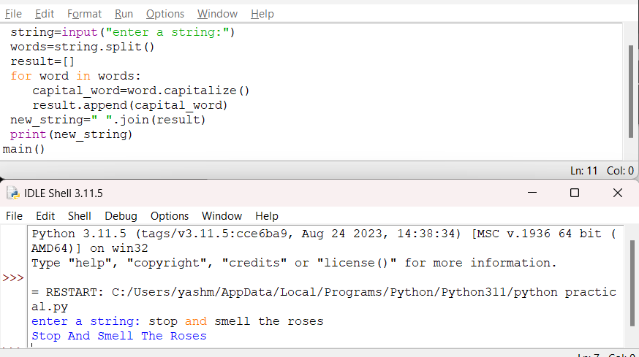**OUTPUT:**

**PROGRAM 6**

A) **Write a program that accepts a list from user. Your program should reverse the content of list and display it. Do not use reverse () method.**

**SOLUTION:**

l1=input("Enter some numbers:")

l2=l1.split()

print(l2[::-1])

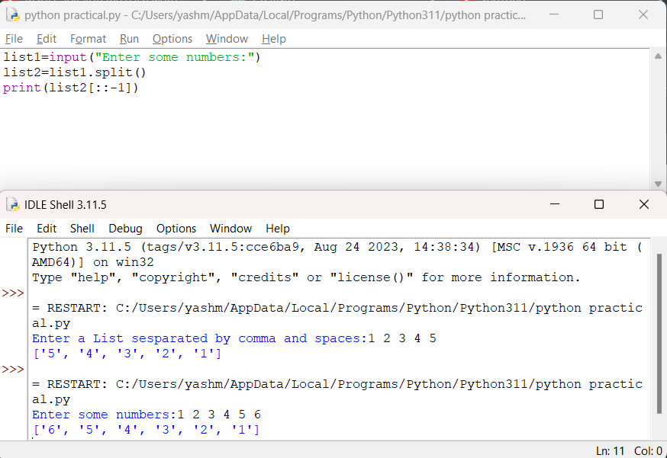**OUTPUT:**

**B) Find and display the largest number of a list without using built-in function max ().Your program should ask the user to input values in list from keyboard.**

**SOLUTON:**

num=input("enter values:")

list1=[int(items) for items in num.replace(","," ").split()]

print(list1)

maximum_value=0

for items in list1:

if items>maximum_value:

maximum_value=items

else:

print("largest number of list is", maximum_value)

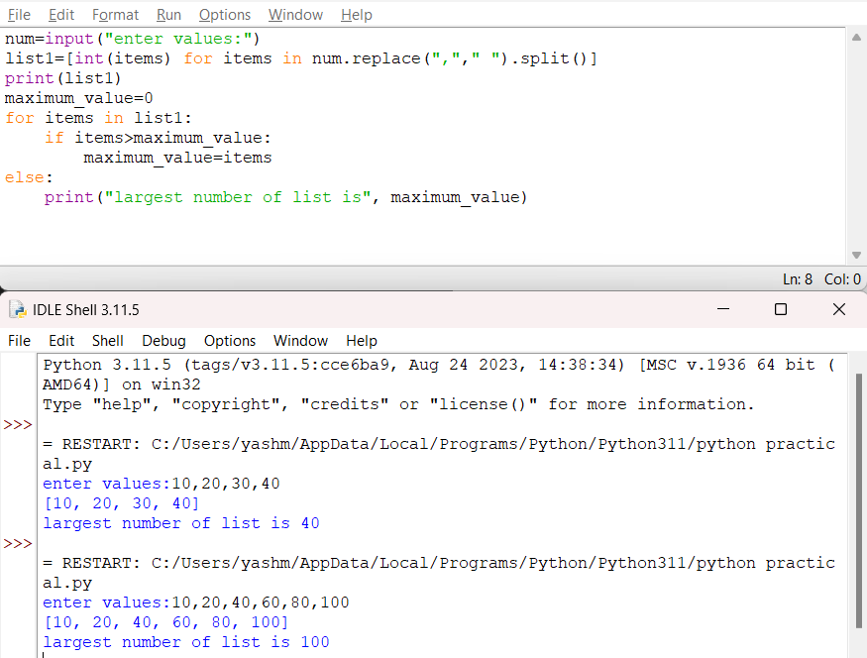**OUTPUT:**

**PROGRAM 7**

**A) Find the sum of each row of matrix of size m x n. For example, for the following matrix output will be like this:**

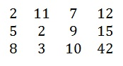

**Sum of row 1 = 32**

**Sum of row 2 = 31**

**Sum of row 3 = 63**

**SOLUTION:**

matrix=[ [2, 11, 7, 12],

[5, 2, 9, 15],

[8, 3, 10, 42]]

m=len(matrix)

n=len(matrix[0])

for i in range(m):

sum_rows=sum(matrix[i])

print(f “sum of rows{i+1}={sum_rows}")

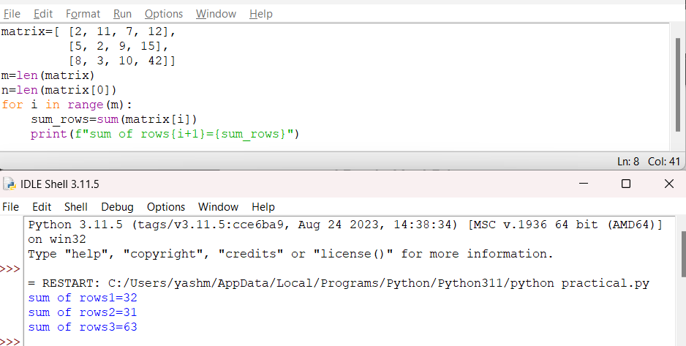**OUTPUT**